5.1 System Properties

In the Control Panel System, you can view information about your computer, such as the edition, the processor and installed RAM, the system type, the computer name, domain, and workgroup settings, and the Windows activation code. You can also access the system properties from here using the left panel, or you can use sysdm.cpl.

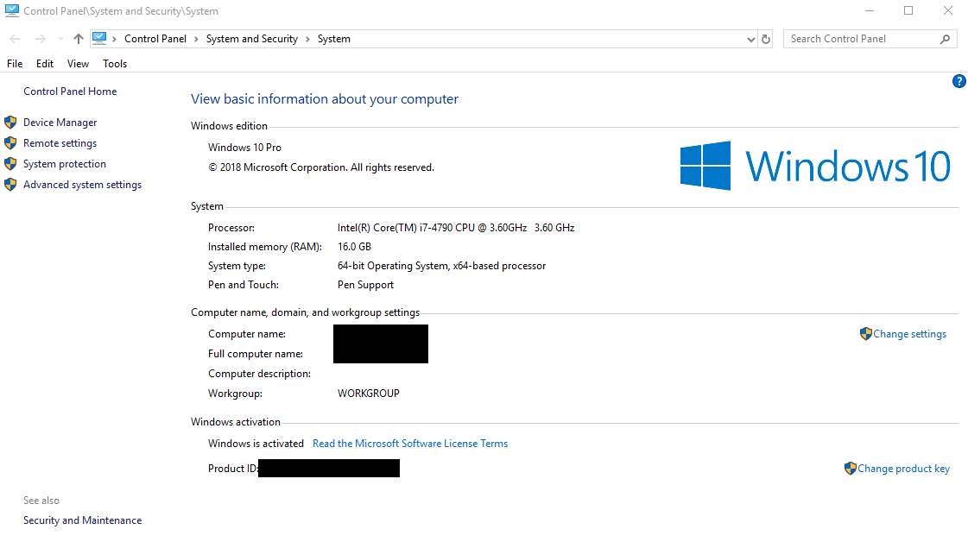

You probably, by now, have used the system properties box at least once before.

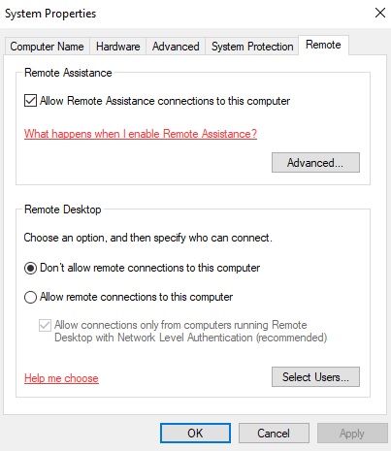

As you can see, there are other tabs besides the Remote tab, and you might have checked them out before. I will go into detail what these tabs are all about.

# Computer Name

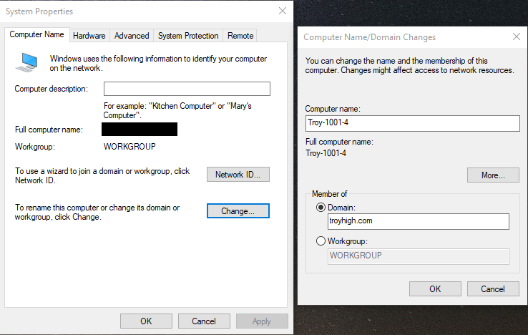

In this tab, you can change your computer name and the network you belong in. As a quick reminder:

* A homegroup is a network of computers in a home
* A workgroup is a network of computers in a workplace
* A domain is a network of computers in a corporation
* Homegroups and workgroups are decentralized; there is no central computer handling all the users and computers etc

Why would you want to rename a computer?

* For the memes
* Organization
* To make tech support much easier
  + Instead of saying “Please fix DESKTOP-DNM5QRM” you could just say “Please fix Troy-1001-4” as in “the 4th computer in room 1001 at Troy”
* You generally would want to rename your servers to something short and simple for quick access in a private network
  + No one wants to access a private web server by typing WIN-5LATHCLO73A.contoso.com
  + DNS does make this easier without needing to rename your computers, however

# Hardware

Not very important in security, important to know for the tech savvy. Here you can access the device manager and change settings for driver updates.

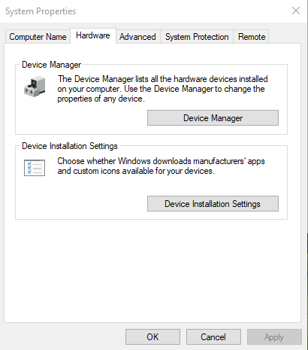

# Advanced

This tab allows you to change performance, handle user profiles, set up settings for startup procedures and recovery from failure, and change environment variables used in the command prompts.

Environment variables are like shorter/easier-to-memorize substitutions for specific commonly used phrases or statistics

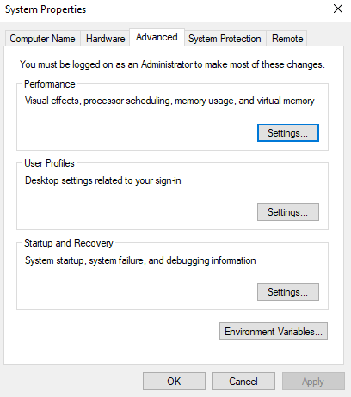

You will probably never use any of these buttons except for the performance button.

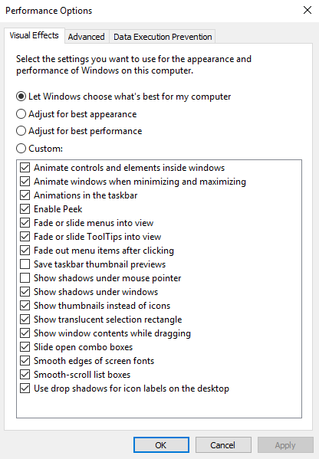

## Visual Effects

In the Performance Options, you can change the settings to boost your performance during competition or make the computer look prettier. The adjustments will not affect much, however - it’s only really useful if your computer is legitimately crawling.

## Advanced (Performance Options)

Under the Advanced tab you will find more adjustments to performance, such as program vs background priority or virtual memory.

There was an option in LSP to clear the virtual memory at shutdown. If you don’t remember what virtual memory is, it is a hard drive used as RAM. It is slower to access, but if you are low on RAM then virtual memory is the way to go. The settings for virtual memory here are to set the limits, specifically how much of the hard drive can Windows use for memory.

## Data Execution Prevention

Now we get to the meat of this entire tab: Data Execution Prevention (DEP). This was a shocker last year - pretty much no one else knew about this. Once again I’d like to stress how important it is to do self research - there are more vulnerabilities that can be scored than you know.

So what is DEP? It performs additional checks on memory to help prevent malicious code from running on a system by using both hardware and software technology.

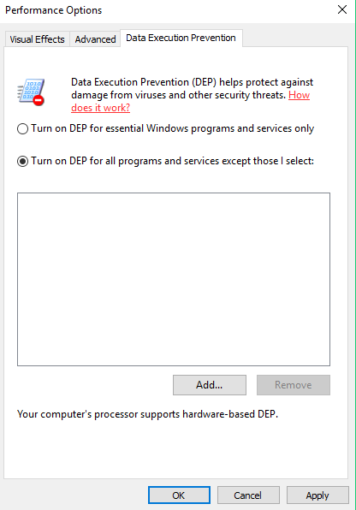

You can use common sense to judge that you’d want this on for all programs and services, not just Windows programs and services.

# System Protection

The System Protection tab allows you to set up a restore point and revert to a restore point. In the real world, you would probably want to set something like this up, but it is not super important during competition.

# Remote

The tab to set certain remoting settings, including Remote Assistance and Remote Desktop. You can also modify which users are allowed to remote desktop in (Administrators are able to remote desktop).